**NATIONAL ACADEMY OF SCIENCE AND TECHNOLOGY**

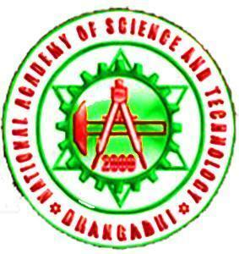

A Project Report On

**THE IMPACT OF THE RUSSIA-UKRAINE WAR IN THE WORLD**



Submitted To: Submitted By:

Mr. Upendra Bahadur Bam Amrit Pant

Class 11 (2022)

Section F

**ACKNOWLEDGEMENT**

I want to express my special Gratitude to **Mr. Upendra Bam sir** who gave me this opportunity to present a report on **THE IMPACT OF THE RUSSIA-UKRAINE WAR IN THE WORLD**. I want to extend my gratitude to my parents who supported and motivated me while doing the Project. I want to thank my friends Ritik Chand, Prasab Kunwar, and Ashish Chand who helped me to finish this report within a limited time. I have also taken some references from websites that are mentioned on the last page.

THANKS TO THE EVERYBODY WHO HELPED ME WITH THIS PRO**J**ECT

Amrit Pant

**Certificate of Completion** 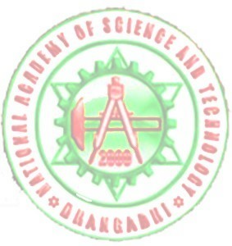

This is to certify that this Project is made by **Amrit Pant** a student of **Class 11 (Section F).** From the **National Academy of Science and Technology** on the topic of **THE IMPACT OF THE RUSSIA UKRAINE WAR IN THE WORLD.** Under the guidance of **Mr. Upendra Bahadur Bam** and have been completed.

**Mr.Upendra Bam Mr. Krishna Bhandari**

**Lecturer of English Lecturer of Chemistry**

**Principle, NAST HOD, Science**

**Table of Contents**

1. Introduction………..…………………………….……………...5
2. Food Security Challenge in Ukraine…………….. .…………6
3. Chances of World War 3 …...……….…..……………………7
4. Conclusion………………………………...…………………...9
5. References …………………..………………………………..11

**Introduction**

The war that began on 24 February 2022 has caused extensive damage and loss of life in major cities in Ukraine, spread across rural areas, and sparked massive population displacement.

More than 3.6 million people had been forced to abandon their homes and flee across borders to safety. Millions more are internally displaced. It is clear that the war has resulted in a massive, and more deteriorating, food insecurity situation, disrupted livelihoods during the agricultural growing season in Ukraine, and has also affected global food security. Already prior to the war in Ukraine, international food commodity prices had reached an all-time high. This was mostly due to market conditions, but also high prices of energy, fertilizers, and all other agricultural services. The conflict has aggravated the situation. In March 2022, the FAO Food Price Index reached a new historical record high, up 12.6 percent from February and 33.6 percent from its level a year earlier, and 15.8 percent higher than the peak reached in February 2011. The Russian Federation and Ukraine are prominent players in the global trade of food and agricultural products. In 2021, wheat exports by the Russian Federation and Ukraine accounted for about 30 percent of the global market. Russia’s global maize export market share is limited, standing at 3 percent between 2016/17 and 2020/21. Ukraine’s maize export share over the same period was more significant, averaging 16 percent and conferring it the spot of the world’s 4th largest maize exporter. Combined, sunflower oil exports from both countries represented 78 percent of the global supply. The Russian Federation is also a key exporter of fertilizers. In 2021, it ranked as the top exporter of nitrogen fertilizers, the second leading supplier of potassium, and the third largest exporter of phosphorous fertilizer in the world.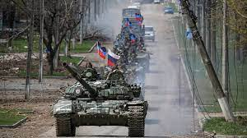

Nearly 50 countries depend on the Russian Federation and Ukraine for at least 30 percent of their wheat import needs. Of these, 26 countries source over 50 percent of their wheat imports from these two countries. In that context, this war will have multiple implications for global markets and food supplies, representing a challenge for food security for many countries, especially for low-income food import-dependent countries and vulnerable population groups

**FOOD SECURITY CHALLENGE**

The war in Ukraine has already caused extensive damage and loss of life in key population centers, spread across rural areas, and sparked massive population displacement. Populations in active war zones are facing severe shortages of food, water, and energy supplies. As insecurity persists and both local and national supply chains are disrupted, people are likely to fall deeper into hunger and malnutrition. . Key immediate areas of concern include:

• disruption to winter harvesting and spring planting;

• agricultural labor availability, impacted by displacement;

• access to and availability of agricultural inputs, particularly fuel, and seeds;

•Diisruption of logistics and all elements of the food supply chains;

• abandonment of and reduced access to agricultural land; • damage to crops due to military activity, especially during vegetative

• destruction of agrifood system assets and infrastructure.

**Chances of WW3**

Russia’s unprovoked war with Ukraine recently entered its eighth month, and there are few signs of it ending anytime soon.

Rather, the fighting appears more likely to escalate. Russian President Vladimir Putin announced last week that he will push 300,000 reservists into service, and his accompanying speech featured some alarming threats. Referencing – without evidence – that the West is engaging in “nuclear blackmail” against Russia, the leader noted that his country “has various means of destruction” and, when threatened, “will certainly use all the means” at their disposal, according to a translation. This comes after Russia reportedly engaged in provocations near a Ukrainian nuclear power plant in August, which a U.S. Department of Defense official described as the “height of irresponsibility.”

A stark new finding from an international survey suggests that the world is taking these threats – and their broader global implications – seriously.

In a study of more than 17,000 people across the world, three-quarters of respondents agreed with the statement, “I fear we are moving closer to World War III.” The findings are culled from the U.S. News & World Report Best Countries survey, which was fielded this year from April 30 to July 13 and is used for annual, perception-based rankings of countries.

**Conclusion**

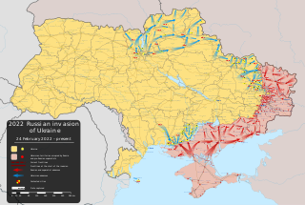

In conclusion, We have to understand that war can never be won completely by a single nation, both nations suffer from severe damage to people and infrastructure. War can also lead to the mass destruction of mankind. To protect and preserve mankind and promote peace we should stand against war and try to stop it.

**References**

<https://www.wikipedia.org>

<https://www.usnews.com>

<https://www.youtube.com>